**Project Design Phase-II**

**Data Flow Diagram & User Stories**

|  |  |
| --- | --- |
| Date | 15 October 2022 |
| Team ID | PNT2022TMID40373 |
| Project Name | Project - AI- Based localisation and classification of skin disease with Erythema |
| Maximum Marks | 4 Marks |

**Data Flow Diagrams:**

Register / login to the webpage

Input Images

Segmentation

Preprocessing

**A Data Flow Diagram (DFD) is a traditional visual representation of the information flows within a syst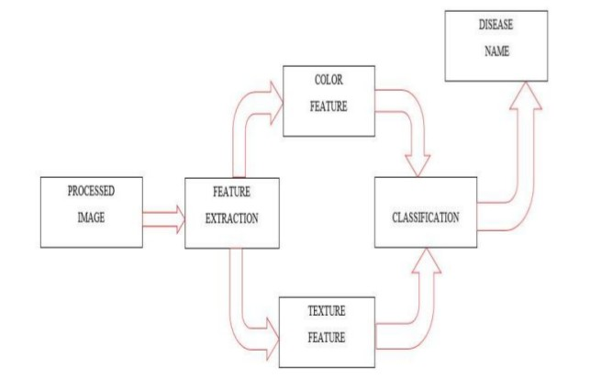em. A neat and clear DFD can depict the right amount of the system requirement graphically. It shows how data enters and leaves the system, what changes the information, and where data is stored.**

**User Stories**

Use the below template to list all the user stories for the product.

| **User Type** | **Functional Requirement (Epic)** | **User Story Number** | **User Story / Task** | **Acceptance criteria** | **Priority** | **Release** |
| --- | --- | --- | --- | --- | --- | --- |
| Customer ( Web user) | Home page | USN-1 | Description about Skin disease | I can get an idea about the disease | Low | Sprint-3 |
|  |  | USN-2 | Details about the test vitals required for the test |  | Low | Sprint-3 |
|  | Registration | USN-3 | As a user, I can register for the application by entering my username, email, phone number, and password and confirmation my password. | I can access my account | Moderate | Sprint-3 |
|  |  | USN-4 | As a user , I will receive a confirmation email once I have registered for the application | I can receive a confirmation OTP upon registration for verification. | High | Sprint-3 |
|  | Login | USN-5 | As a user , I can log in to the web application by entering my mail id & password | I can login successfully | High | Sprint-2 |
|  | Main page ( Test vitals) | USN-6 | As a user, I submit the required image for the prediction. | I can access the page and can submit the input | Moderate | Sprint-4 |
|  | Results | USN-7 | Results will be displayed along with their accuracy | I got my results successfully and accurately | High | Sprint-4 |
| Administrative | Data collection | USN-8 | Collect the required data for the detection of skin disease. |  | High | Sprint-1 |
|  | Data preprocessing | UNS-9 | Clean and analyse the data to avoid noise and duplications | As a result I get the desired data set. | High | Sprint-1 |
|  | Model building | USN-10 | Build the model using a random classifiers to classify the images | Successfully trained the model | High | Sprint-1 |
|  | Deploy the model | USN-11 | Deployment of ML model using IBM Watson Studio, Object storage. | Deployed successfully | High | Sprint-2 |
|  | Integrated the web app with the IBM model | USN-12 | Use flask for the integration purpose | Create the web app successfully | Moderate | Sprint-2 |